**In Memory**

**Sons in Retirement Branch 116 wishes to express our deepest sorrow in the passing of:**

**Art D. Shingleton**

**Les was more than just a member of SIR but a friend to all as well as an active participant in many our activities.**

**Les will be greatly missed.**

**Arthur Vogl** 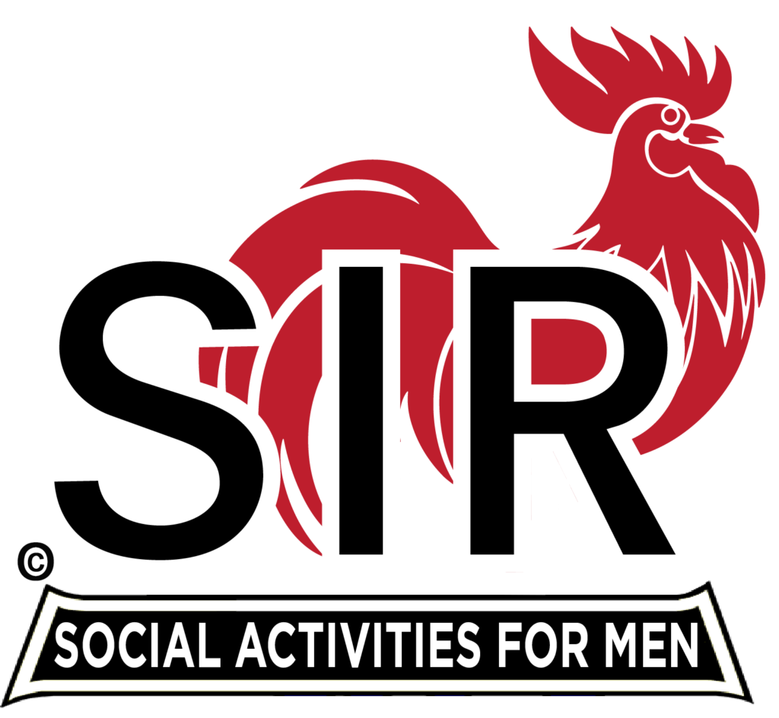

**2013 Big SIR, Branch 116**